SHAP
SHAP = SHapley Additive exPlanations
SHAP is based on Shapley values, a concept from cooperative game theory.
The basic idea is:
Treat the model prediction as a "payout" and the input features as players who cooperatively produce that payout.
SHAP calculates how much each feature contributed to moving a prediction away from a baseline prediction.
For example:
Suppose:
Average model prediction = 0.40
Prediction for this customer = 0.82
SHAP might explain the difference as:
Baseline 0.40
Age +0.10
Income +0.18
Debt -0.03
Credit score +0.12
-----
Final prediction 0.77
The exact values depend on the model and SHAP explainer/output space, but the principle is:
Prediction=Baseline+∑_{i}SHAP_{i}

Why Do We Need SHAP?
Consider a model:
y=f(x1,x2,x3,…,xn)
The model may tell us:
f(x)=0.91
but this doesn't tell us why.
SHAP decomposes the prediction:
f(x)=ϕ0+ϕ1+ϕ2+⋯+ϕn
where:
- ϕ0 = expected/baseline model output
- ϕi = contribution of feature ii
Therefore:
f(x)=E[f(X)]+∑i=1nϕi
This is the fundamental SHAP equation.

Shapley Values
The mathematical foundation of SHAP comes from Shapley values.
Suppose we have three features:
Age
Income
Credit Score
We want to determine how much Income contributes to the prediction.
Income can be added to different feature subsets:
{}
{Age}
{Credit Score}
{Age, Credit Score}
We compare the model output:
v(S∪{i})−v(S)
where:
- S = subset of features
- i = feature being evaluated
- v(S) = model output using features in SS
The contribution is averaged over all possible feature orderings.

Mathematical Formula of SHAP

Shapley values for a 3 player game
Before we move on, let’s walk through another example. This will make the general equation easier to understand. This time we have a team of 3 players. The calculations are complicated and we’ll have to go back in time a few more times.
There will now be 8 possible coalitions seen below. Together you win first prize ($10,000). There are now 3 coalitions of 2 players. For example, a coalition of P1 and P3 would come second ($7,500). There will also be coalitions of 1 Player. For example, if P3 played alone they would not make any prize money ($0). Perhaps they should have invested in a better GPU.
Press enter or click to view image in full size
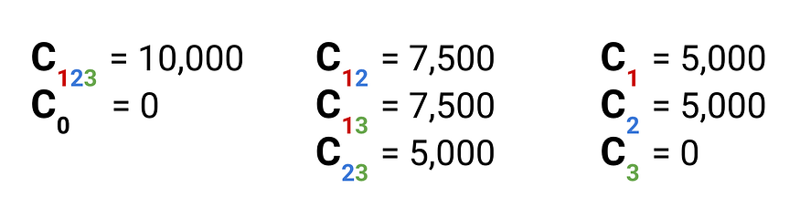
Coalition values
We can use these coalition values to calculate the Shapley value for P1. There are now 4 coalitions that P1 could join. P1 can join a coalition of both P2 and P3, a coalition of only P2 or P3 or a coalition of no players. Like before, we calculate the marginal contributions of P1 to each of these coalitions. Finally, we take the weighted average. This gives us a Shapley value of $5,000.
Press enter or click to view image in full size
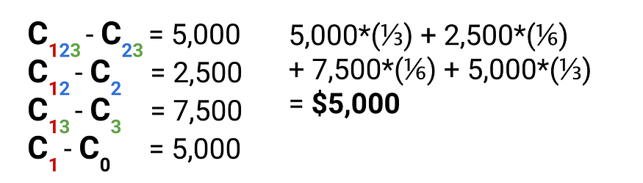
Expected marginal contribution for Player 1 (source: author)
The question you may be asking is where do we get these weights from? That is why do we weight the first marginal contribution by 1/3, the second by 1/6 and so on… These are the probabilities that P1 makes those specific contributions. Weighting by probabilities gives us an expected marginal contribution.
It’s not obvious where these probabilities come from. To start, we need to work out the number of ways a coalition of 3 people can be formed. This is because the full prize money ($10,000) can only be won if all 3 members work together.
To do this, we assume each member joins the team sequentially with equal chance. For example, P1 joins then P3 then P2. This gives us a total of 3! = 6 ways of forming the coalition. You can see all of these below. In general, there are n! ways of forming a team of n players.
Press enter or click to view image in full size
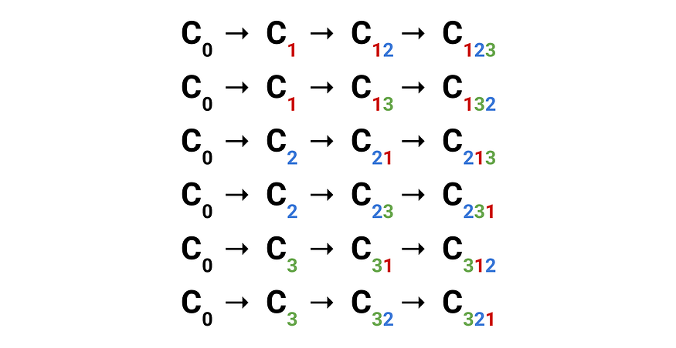
6 ways of forming a 3 Player coalition (source: author)
Above we saw that if P1 joins a coalition of P2 and P3 they will make a marginal contribution of $5000. This can happen in two ways. Either P2 joins then P3 then P1 or P3 joins then P2 then P1. In other words, P1 will make this marginal contribution for 2 of the 6 ways the team can form. This gives us a probability of 2/6 = 1/3 that P1 makes this contribution.
There is only one way that P1 can make the second contribution ($2,500). That is if P2 joins then P1 then P3. This gives us a probability of 1/6. Similarly, the third contribution ($7,500) has a probability of 1/6. The fourth contribution ($5000) has a probability of 1/3. Like with the first contribution there are two ways for P1 to make it. First P1 joins then P2 then P3 or P3 then P2.
We can follow the same process for P2 and P3. For these players, the Shapley values turn out to be $3,750 and $1,250 respectively. Again, all the Shapley values add up to the total prize money. Shapley values will always divide all the prize money fairly. Now let’s see how we can generalise the Shapley value.

Generalised Shapley values
Equation 1 gives the formula for the Shapley value of player i of a p player game. Starting with the summation sign, we are summing over all coalitions S. Where S is the subset of coalitions that do not include Player i. In other words, S contains all the coalitions to which Player i is able to make a marginal contribution. Going back to the 3 player example, there were 4 coalitions that did not include P1.
Press enter or click to view image in full size
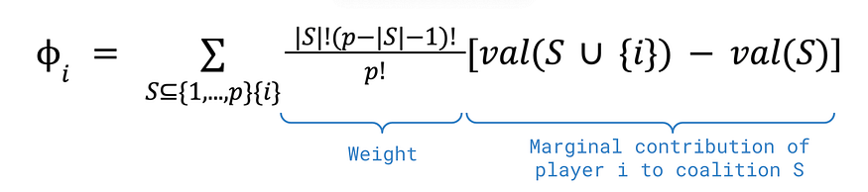
Equation 1: shapley value for player i of a p player game (source: author)
Within the square bracket, we have the marginal contribution of player i to coalition S. Specifically, we have the value (val) of coalition S including Player i less the value of coalition S. The value function depends on the particular game that is being played. In our 3 player example, we used different notation. We spoke about coalition values and used the letter C with player subscripts. These coalition values give the value function for the Kaggle game.
Lastly, we weight the marginal contributions. Below, you can see what each of the components of the weight represents. Here |S| is the number of players in coalition S. This means p-|S|-1 is the number of players that need to join the coalition after player i.
Press enter or click to view image in full size
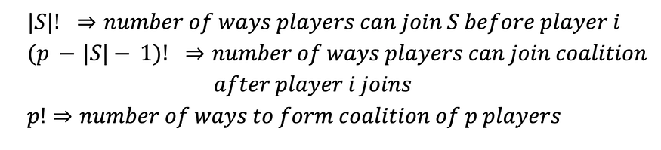
In the weights numerator, we have the number of ways the coalition S can form. The denominator is the number of ways the full team can form. So, the weight gives the probability that player i makes a contribution to a coalition of size |S| when there are p players in the game. If you sub in the values for our 3-player game you would get the same weights as before.
Breaking down the Shapley value, you can see that it has an intuitive explanation. We are weighting all the marginal contributions of player i by the probabilities that they make the contributions. We then sum these weighted contributions over all the coalitions that player i can join. This gives us an expected marginal contribution. Using these values, we can divide the total value of the game among all the players.
Intuitively, it may seem that the expected marginal contribution is a fair way to do this. We consider contributions to all coalitions. This means we take into account a player’s individual contribution and the interactions between players. That is some players may work well together increasing their joint value. The problem is there could be other ways to divide value that also seem fair. We need to prove the Shapley value is fair.

Shapely axioms
The Shapley value is actually derived from 3 axioms. We will only summarise them but they can also be defined mathematically. These axioms can be considered a definition of fairness. Hence, a method of dividing value that satisfies this definition can be considered fair.
Symmetry Two players are considered interchangeable if they make the same contributions to all coalitions. If two players are interchangeable then they must be given an equal share of the game’s total value.
Null player property If a player makes zero marginal contribution to all coalitions then they get none of the total value.
Additivity If we combine two games, then a player’s overall contribution is the sum of the contributions for the two individual games. This axiom makes the assumption that any games played are independent.
We can prove mathematically that the Shapley value is the only efficient value that satisfies these 3 axioms. By efficient, we mean none of the game's value is left over. Ultimately, under this definition, the Shapley value is the only fair way to divide value. It is amazing that such an intuitive formula can be derived from 3 simple axioms.

Intuition Behind the Formula
Imagine four friends contribute to a project:
Alice
Bob
Charlie
David
The final profit is $100.
We want to determine how much Bob contributed.
We could calculate Bob's contribution by considering:
Bob alone

Bob + Alice

Bob + Charlie

Bob + David

Bob + Alice + Charlie

Bob + Alice + David

...
For every possible coalition:
Marginal contribution=value with Bob−value without Bob\text{Marginal contribution} = \text{value with Bob} - \text{value without Bob}
Then we take a properly weighted average.
SHAP applies exactly this idea to ML features.

Simple SHAP Example
Suppose a house-price model predicts:
$500,000\$500,000
The average prediction is:
$350,000\$350,000
SHAP might produce:
Feature | SHAP value
Size | +80,000
Location | +50,000
Bedrooms | +20,000
Age | -10,000
Garage | +10,000
Then:
350,000+80,000+50,000+20,000−10,000+10,000350,000+80,000+50,000+20,000-10,000+10,000 =500,000=500,000
So the SHAP explanation is:
Baseline $350k
Size +$80k
Location +$50k
Bedrooms +$20k
Age -$10k
Garage +$10k
-------
Prediction $500k

Important Properties of SHAP
SHAP has several desirable theoretical properties.

8.1 Local Accuracy
The individual SHAP values add up to the model output:
f(x)=ϕ0+∑iϕif(x)=\phi_0+\sum_i\phi_i
This is sometimes called local accuracy or efficiency.

8.2 Missingness
If a feature is missing or has no contribution under the formulation, its SHAP contribution is zero.

8.3 Consistency
If a model changes so that a feature's contribution increases while everything else remains appropriately comparable, its SHAP importance should not decrease.
This is one reason SHAP is attractive compared with some heuristic feature-importance approaches.

SHAP Values: Positive vs Negative
The sign of a SHAP value tells us the direction of contribution.

Positive SHAP value
The feature pushes the prediction higher.

Negative SHAP value
The feature pushes the prediction lower.
Example:
Prediction = 0.82

Feature A = +0.20
Feature B = +0.10
Feature C = -0.05
Interpretation:
A increases prediction
B increases prediction
C decreases prediction

SHAP Value vs Feature Importance
Traditional feature importance might say:
Income 35%
Age 20%
Credit score 18%
Debt 15%
Other 12%
This tells us which features are important globally.
SHAP can additionally tell us:
For customer #152:

Income +0.31
Age -0.04
Credit score +0.17
Debt -0.21
So SHAP provides both:

Global explanation
"What generally matters?"
and

Local explanation
"Why did this particular observation receive this prediction?"

SHAP Explainers
The SHAP library provides different explainers for different model types.
Common ones include:

TreeExplainer
Designed for tree-based models:
- XGBoost
- LightGBM
- CatBoost
- Random Forest
- Decision Trees
Example:
import shap

explainer = shap.TreeExplainer(model)
shap_values = explainer(X_test)

LinearExplainer
For linear models such as:
- Linear Regression
- Logistic Regression
explainer = shap.LinearExplainer(model, X_train)
shap_values = explainer(X_test)

KernelExplainer
A model-agnostic approach.
It can work with many models because it treats the model as a black box.
explainer = shap.KernelExplainer(
model.predict,
X_background
)

shap_values = explainer.shap_values(X_test)
However, Kernel SHAP can be computationally expensive.

DeepExplainer
Designed for certain deep-learning models.
explainer = shap.DeepExplainer(
model,
background_data
)

PartitionExplainer
Useful for structured/high-dimensional data and feature dependencies in suitable settings.

Major SHAP Plots
SHAP has several important visualization methods.
The most important ones to know are:
- Waterfall plot
- Force plot
- Beeswarm plot
- Bar plot
- Dependence scatter plot
- Interaction values/interaction plot
- Heatmap
- Decision plot
- Monitoring/summary-style visualizations depending on the SHAP version
Let's understand them one by one.

SHAP Waterfall Plot
The waterfall plot explains one individual prediction.
It shows how the prediction moves from the baseline to the final prediction.
Example concept:
Baseline
0.42
|
Income +0.20
|
Age +0.10
|
Debt -0.08
|
Score +0.15
|
Prediction
0.79

Python
shap.plots.waterfall(shap_values[0])
This is one of the best plots for explaining an individual observation.

Use case
A bank employee asks:
Why was this particular customer's loan risk predicted as high?
Use a waterfall plot.

SHAP Force Plot
A force plot shows the same basic idea in a more compact visual format.
Conceptually:
Low prediction <------ baseline ------> High prediction

Feature A
←

Feature B →
Feature C →
Python:
shap.plots.force(shap_values[0])
or, depending on SHAP version/API:
shap.force_plot(
explainer.expected_value,
shap_values[0].values,
X_test.iloc[0]
)
Force plots are particularly useful in interactive notebooks.

SHAP Beeswarm Plot
The beeswarm plot is one of the most important SHAP plots.
It provides a global overview of feature importance and direction.
shap.plots.beeswarm(shap_values)
It shows:
- features on the y-axis
- SHAP values on the x-axis
- each point = an observation
- color = feature value
Typical interpretation:
Feature A ← negative positive →
Feature B ●●●●●
Feature C ●●● ●●●●
Feature D ●● ●●
Features at the top generally have larger overall impact.

How to Read a Beeswarm Plot
Suppose:
Income
red points → right
blue points → left
This suggests:
High income tends to increase the model output, while low income tends to decrease it.
If the pattern is reversed:
red points → left
blue points → right
then:
High income tends to decrease the prediction, while low income tends to increase it.
This is much more informative than ordinary feature importance.

SHAP Bar Plot
The SHAP bar plot summarizes feature importance.
shap.plots.bar(shap_values)
Typically the importance is based on:
Mean Absolute SHAP=1n∑j=1n∣ϕij∣
For feature i:
Ii=1N∑j=1N∣ϕij∣
This tells us how strongly a feature affects predictions on average.

Important distinction
A high mean absolute SHAP value means:
The feature has a large effect.
It does not necessarily mean:
The feature always increases the prediction.

SHAP Dependence Plot
A dependence plot examines the relationship between:
Feature value
vs
SHAP value
Modern SHAP syntax:
shap.plots.scatter(
shap_values[:, "Age"]
)
Or in some older versions:
shap.dependence_plot(
"Age",
shap_values.values,
X_test
)
Suppose we plot:
Age → SHAP value
We can discover:
- linear effects
- nonlinear effects
- thresholds
- saturation
- outliers
- interactions

Example of Dependence Plot Interpretation
Imagine:
SHAP
+0.5 | ●●
| ●●
+0.2 | ●●
| ●●
0 | ●●
|
-0.3 |●
+------------------
Age
Interpretation:
Increasing age initially reduces the prediction, but after a certain point its effect becomes positive.
This can reveal nonlinear behavior that ordinary correlation may miss.

SHAP Interaction Values
Features can interact.
For example:
Income
Credit Score
Income may have a different effect depending on credit score.
SHAP can estimate pairwise interaction effects.
For suitable models:
interaction_values = explainer.shap_interaction_values(X_test)
For tree models, this is particularly useful.
Conceptually:
ϕij\phi_{ij}
represents the interaction between feature ii and feature jj.
A dependence plot can also color points by another feature:
shap.plots.scatter(
shap_values[:, "Age"],
color=shap_values[:, "Income"]
)
This can reveal interaction patterns.

SHAP Heatmap
A heatmap can display SHAP values across many observations.
shap.plots.heatmap(shap_values)
Conceptually:
Feature
A B C D
Sample 1 + - + 0
Sample 2 - + + -
Sample 3 + + - +
Sample 4 0 - + -
This is useful for identifying patterns across observations.

SHAP Decision Plot
A decision plot shows how multiple features move predictions from the baseline toward their final values.
shap.plots.decision(
shap_values.base_values,
shap_values.values,
X_test
)
It is useful for:
- comparing multiple observations
- seeing prediction paths
- understanding cumulative feature effects

SHAP Summary Plot
In older versions of SHAP, this was commonly called:
shap.summary_plot(shap_values, X_test)
For example:
shap.summary_plot(
shap_values.values,
X_test
)
The modern equivalent is generally:
shap.plots.beeswarm(shap_values)

SHAP and Binary Classification
Binary classification has:
y∈{0,1}y\in\{0,1\}
Examples:
Fraud / Not Fraud
Disease / No Disease
Default / No Default
Spam / Not Spam
Suppose:
model.predict_proba(X_test)
returns:
Class 0 Class 1
0.20 0.80
The model predicts:
P(Y=1)=0.80P(Y=1)=0.80

SHAP for Binary Classification
For binary classification, SHAP can explain the model output for the selected class/output space.
Depending on the model and SHAP version, the output may be:
- probability
- raw model score
- log-odds/margin
This distinction is very important.
For some classifiers, TreeExplainer's default output may be in the model's raw space rather than probability space.
Therefore, always check what your SHAP values represent.

Binary Classification Example
import shap

explainer = shap.TreeExplainer(model)

shap_values = explainer(X_test)

print(shap_values.shape)
Then:
shap.plots.beeswarm(shap_values)
For one observation:
shap.plots.waterfall(shap_values[0])
The interpretation is:
Which features pushed the model's output toward one class versus the other?

SHAP for Multiclass Classification
Suppose we have:
Class 0 = Cat
Class 1 = Dog
Class 2 = Rabbit
Then:
Y∈{0,1,2}Y\in\{0,1,2\}
A model produces:
Cat 0.20
Dog 0.65
Rabbit 0.15
The SHAP explanation is generally class-specific.
You can ask:
Why did the model predict Dog?
Then you examine SHAP values for the Dog output.

Multiclass SHAP Concept
For KK classes, conceptually:
fk(x)=E[fk(X)]+∑iϕi
where:
- k = class
- ϕi,k = contribution of feature ii to class kk
So:
Feature
↓

Class 0 Class 1 Class 2
Feature A +0.10 -0.20 +0.05
Feature B -0.05 +0.30 -0.10
Feature C +0.20 -0.15 -0.05
A feature can therefore support one class while opposing another.

Multiclass Python Example
Depending on the SHAP version/model, multiclass outputs can be represented differently.
A robust modern approach is to inspect the returned Explanation object:
shap_values = explainer(X_test)

print(type(shap_values))
print(shap_values.values.shape)
Then determine which dimension corresponds to the classes.
For a specific class, use the corresponding class slice when the returned object is class-indexed.
For example, conceptually:
class_id = 1

class_shap = shap_values[..., class_id]

shap.plots.beeswarm(class_shap)
The exact indexing should be checked against the SHAP version being used because SHAP's multiclass output representation has evolved between versions.

Multiclass Waterfall Plot
Suppose class 1 is "Dog".
We can explain one prediction for Dog:
class_id = 1

class_shap = shap_values[..., class_id]

shap.plots.waterfall(class_shap[0])
Interpretation:
Feature A → pushes toward Dog
Feature B → pushes away from Dog
Feature C → pushes toward Dog

SHAP with Pandas
It is strongly recommended to preserve feature names.
Good:
X_test = pd.DataFrame(
X_test,
columns=feature_names
)
Then:
shap_values = explainer(X_test)
This produces much more readable plots.
Instead of:
Feature 0
Feature 1
Feature 2
you get:
Age
Income
Credit Score

SHAP Complexity
Exact Shapley-value calculation is computationally expensive.
With nn features, there are:
2n2^n
possible subsets.
For:
n = 10
there are:
210=10242^{10}=1024
subsets.
For:
n = 30
there are:
2302^{30}
which is over one billion subsets.
Therefore, exact brute-force calculation becomes impractical.
SHAP uses efficient algorithms/approximations depending on the model and explainer.

SHAP Limitations
SHAP is powerful, but it is not perfect.
This is extremely important in exams and real-world projects.

Limitation 1: Computational Cost
Some explainers, particularly model-agnostic approaches such as Kernel SHAP, can be expensive.
For large datasets:
Millions of rows
Hundreds/thousands of features
SHAP calculations may become expensive.

Limitation 2: Feature Correlation
This is one of the most important limitations.
Suppose:
House size
Number of rooms
are highly correlated.
The model may use both.
SHAP must determine how credit is allocated among correlated features.
This can produce unintuitive attribution.
For example:
House size +0.30
Number of rooms +0.05
even though both represent similar information.

Limitation 3: SHAP Is Not Causality
This is perhaps the most important conceptual warning.
Suppose SHAP says:
Age → +0.20
It does not mean:
Increasing someone's age will cause the prediction to increase by 0.20.
SHAP explains the model's behavior.
It does not establish:
X→YX\rightarrow Y
in the causal sense.
Therefore:
SHAP explanation≠causal explanation\boxed{\text{SHAP explanation} \neq \text{causal explanation}}

Limitation 4: Model Dependence
Different models can produce very different SHAP explanations.
For example:
Random Forest
XGBoost
Logistic Regression
Neural Network
may all achieve similar accuracy but use different relationships.
Therefore SHAP explains:
the fitted model\text{the fitted model}
not necessarily:
the real-world process\text{the real-world process}

Limitation 5: Local vs Global Confusion
A local explanation:
Customer A
doesn't necessarily describe:
Customer B
Similarly, global feature importance does not explain every individual prediction.
SHAP supports both local and global analysis, but they answer different questions.

Limitation 6: Human Interpretation
Even if SHAP provides mathematically correct values, users can still misunderstand them.
For example:
Feature A = +0.27
Feature B = -0.19
Feature C = +0.12
This requires understanding:
- baseline
- output space
- feature dependencies
- model behavior
- sign
- magnitude
Therefore, SHAP should be combined with domain knowledge.

SHAP vs LIME
Both are popular XAI methods.
Property | SHAP | LIME
Main foundation | Game theory | Local surrogate
Explanation | Feature contribution | Local approximation
Theoretical properties | Strong | More heuristic
Global analysis | Strong | Primarily local
Model agnostic | Some explainers | Yes
Tree-specific optimization | Tree SHAP | No
Computational cost | Depends on explainer | Can be expensive
Feature interactions | Can analyze | Limited
Consistency property | Yes | Not guaranteed
A simple way to remember:
LIME asks: "Can I approximate the model around this point?"
SHAP asks: "How should the prediction be fairly allocated among the features?"

How to Explain SHAP in an Exam
A strong definition is:
SHAP (SHapley Additive exPlanations) is an Explainable AI technique based on Shapley values from cooperative game theory. It explains a model prediction by assigning each feature a contribution value representing how that feature moves the prediction away from a baseline. SHAP provides both local explanations for individual predictions and global insights into feature importance, while satisfying desirable properties such as local accuracy, missingness, and consistency.

Most Important Formula to Remember
The central formula is:
f(x)=E[f(X)]+∑i=1nϕi
and:
ϕi=∑S⊆N∖{i}∣S∣!(n−∣S∣−1)!n![v(S∪{i})−v(S)]
If you understand these two equations, you understand the mathematical foundation of SHAP.

One-Line Meaning of Every Major SHAP Plot
Plot | Main purpose
Bar | Overall feature importance
Beeswarm | Importance + direction + distribution
Waterfall | Explain one prediction
Force | Visualize feature forces for a prediction
Scatter/Dependence | Feature value vs SHAP effect
Interaction | Examine feature interactions
Heatmap | SHAP patterns across observations
Decision | Show cumulative prediction paths

Final Summary
SHAP can be remembered through five questions:

1. What is SHAP?
A feature-attribution method based on Shapley values.

2. What does a SHAP value mean?
It represents the contribution of a feature to a particular model output relative to a baseline.

3. What does the sign mean?
+→pushes prediction upward+\rightarrow \text{pushes prediction upward} −→pushes prediction downward-\rightarrow \text{pushes prediction downward}

4. What do the plots tell us?
Bar → What matters?
Beeswarm → What matters + direction?
Waterfall → Why this prediction?
Scatter → How does a feature affect prediction?
Heatmap → How do explanations vary across samples?
Decision → How do features cumulatively change prediction?

5. What should we NOT conclude?
Most importantly:
SHAP association/model attribution≠causality\boxed
SHAP explains what the model is doing, not necessarily what causes the real-world outcome.

